Impressions of Sameed Ahmed

I am grateful for creating a platform to bring youth like me close to nature and in inspiring us in understand the world in your words. I believe that there must be no yatri had left yatra without any learning and self-reflection. There were many queries I had during the yatra and you cleared them about organization working and discipline, I was happy that from the past attempts were being made to reach youth. As organization is having no goal every event completion smoothly is a good sign about the policies of organization.

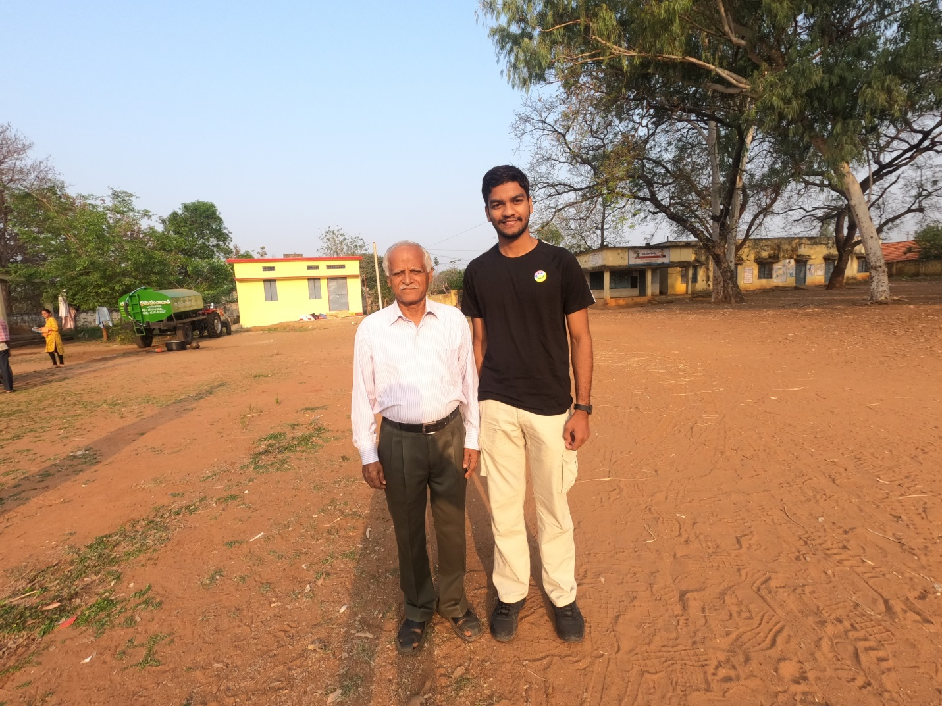

Here, directly I will mention some GLOWS and GROWS points:

GLOWS:
# No agenda No goal is helping everyone to not set expectations, later getting disappointed.
# Impressions from an individual are helping them to come out of comfort zone in opening-up
# Silent walk is a big booster to think about self and reflect.
# Storytelling when we take a break is pushing the thoughts, helping us know the efforts, pain and then impact.
# In charges for volunteering is helping to take ownership and experience true volunteering.

GROWS:
1. The focus should be on female yatris which can be done by approaching women colleges and women organizations, self-help groups.
2. Giving a particular topic of high concerns while walking to discuss and reflect can give some solutions.
3. Dividing yatris into groups and switching them timely without following the same set of people can help people to reach everyone in the Yatra.
4. As whenever we were taking tea break and we were using plastic cups and just throwing them (not every time ) instead if we have a bag to collect cups, plates definitely it will help in not polluting the land.
5. As we were moving village to village interacting students and villagers they were still who didn't get a brochure to read or what is org about, for that if we are able to paste posters in some main places of village and classroom for igniting ideas hope it will be a reminder for them.
6. Wherein the end of yatra placing a banner acting as a photo booth for yatris (the text on a banner like I have completed Palle Srujana Yatra successfully or any good words)

I have learnt many things from this yatra and will be trying to be a part of the journey of Palle Srujana by participating, suggesting and learning thanks to Palle Srujana team for their hospitality and the most memorable experiences.

Sameed Ahmed

